Scalars and Vectors
1. Overview
This lecture introduces two basic building blocks of linear algebra:
- Scalar
- Vector
The main focus is understanding these concepts from a Data Science perspective, while also seeing how the same ideas appear in physics, mathematics, and computer science.
The most important idea to carry forward is:
Scalars represent individual numerical values, while vectors allow us to represent multiple related values together.
This becomes important because, in Data Science and ML, individual data records can be represented as vectors.

2. Scalar
What is a scalar?
A scalar is a single numerical value.
It represents:
- A magnitude
- A quantity
- No direction
Examples:
$$45\text{ km/h} \\ {25}^{∘}C$$
Here, the important numerical values are 45 and 25. They describe a quantity but do not specify a direction.
Simple way to remember
Scalar = One numerical value

Scalar in Data Science
Scalars are everywhere in a dataset because individual calculations often produce a single number.
For example, suppose a dataset contains 5 records.
Number of records
$$\text{Count}=5$$
The result is a scalar because the result is just one number.
Average age
Suppose the ages are:
$$\left[20 , 25 , 30 , 35 , 40\right]$$
Then:
$$\text{Average}=\frac{20+25+30+35+40}{5}=30$$
The result:
$$\boxed{30}$$
is a scalar.
The lecture specifically uses record count and average of a feature as examples of scalar quantities in Data Science.

Scalar in Linear Regression
Consider the equation:
$$\boxed{y=mx+c}$$
where:
- $x$= input
- $y$= output
- $m$= slope
- $c$= intercept
The lecture points out that $c$, the intercept, can be considered a scalar because it is a single numerical value.
For example:
$$y=2x+5$$
Here:
$$c=5$$
So $c$is a scalar.
Important
The lecture deliberately avoids treating $m$as a scalar in this particular discussion because its value is determined from the data points. The focus here is simply to understand the idea of a scalar as a single numerical value.

3. Vector
What is a vector?
The lecture gives two perspectives.
Physics perspective
A vector is a quantity having:
- Magnitude
- Direction
For example:
A car is moving at 45 km/h toward the East.
Here:
- 45 km/h → magnitude
- East → direction
So velocity is a vector quantity.

Data Science perspective
For Data Science, the more useful definition is:
A vector is an ordered list of numbers that can represent a point, observation, or collection of related quantities.
For example:
$$\boxed{\left[90 , 3\right]}$$
could represent:
- IQ = 90
- Study hours = 3
The order matters.
$$\left[90 , 3\right]≠\left[3 , 90\right]$$
because the first value and second value have different meanings.
The lecture specifically defines a vector as an ordered list of numbers and uses student IQ and study hours as an example.

4. Magnitude vs Unit
This is a small point, but it is useful to understand.
Suppose:
$$3\text{ hours}$$
Here:
- 3 = magnitude
- hours = unit
Similarly:
$$45\text{ km/h}$$
- 45 = numerical magnitude
- km/h = unit
When we represent data mathematically, we generally work with the numerical values, while the units provide their real-world meaning.
The lecture highlights this distinction using the study-hours example.

5. Vectors in a Dataset
Consider this dataset:
IQ | Study Hours | Result
90 | 2 | Fail
100 | 2 | Pass
The first two columns are input features.
For the first student:
$$\boxed{x=\left[90 , 2\right]}$$
For the second:
$$\boxed{x=\left[100 , 2\right]}$$
Each student can therefore be represented by a vector.
The result can also be represented numerically, for example:
$$\text{Fail}=0 \\ \text{Pass}=1$$
The lecture uses exactly this type of example to demonstrate how individual records become vectors in ML.
Why is this important?
An ML model cannot directly perform mathematical operations on concepts like:
"IQ = 90, studied for 2 hours, failed."
Instead, it needs numerical representations.
So:
$$\boxed{\text{Data record}→\text{Numerical features}→\text{Vector}}$$

6. Vectors Can Represent More Than Spatial Directions
This is an important point for Data Science.
When you first learn vectors in physics, you may think:
"A vector must have a physical direction."
That's not how you should think about vectors in Data Science.
In Data Science, a vector can simply represent a collection of values.
For example:
$$\left[70 , 72 , 75 , 73\right]$$
could represent a person's weight over four months:
- January → 70 kg
- February → 72 kg
- March → 75 kg
- April → 73 kg
This is a 4-dimensional vector in the mathematical/data representation sense.
There is no need to imagine a physical arrow pointing somewhere.
Remember
Physics: vector → magnitude + physical direction
Data Science: vector → ordered numerical representation
Both are valid contexts, but the Data Science interpretation is particularly important for this course.

7. Vector Dimensions
The dimension of a vector is the number of components/values it contains.
One dimension
$$x=\left[5\right]$$
There is one component.
$$\boxed{1D}$$
Two dimensions
$$x=\left[5 , 8\right]$$
There are two components.
$$\boxed{2D}$$
Three dimensions
$$x=\left[5 , 8 , 2\right]$$
There are three components.
$$\boxed{3D}$$
Four dimensions
$$x=\left[5 , 8 , 2 , 7\right]$$
There are four components.
$$\boxed{4D}$$
And the same idea works for much higher dimensions.
For example:
$$\left[x_{1} , x_{2} , … , x_{500}\right]$$
is a:
$$\boxed{500\text{-dimensional vector}}$$
The lecture emphasizes that vectors can have two, three, 500, or even 5000 dimensions even though humans cannot directly visualize all those dimensions.

8. Visualizing a 2D Vector
Suppose:
$$A=\left[\begin{matrix}1 \\ 2\end{matrix}\right]$$
This is a 2D vector.
We can represent it on a coordinate system.
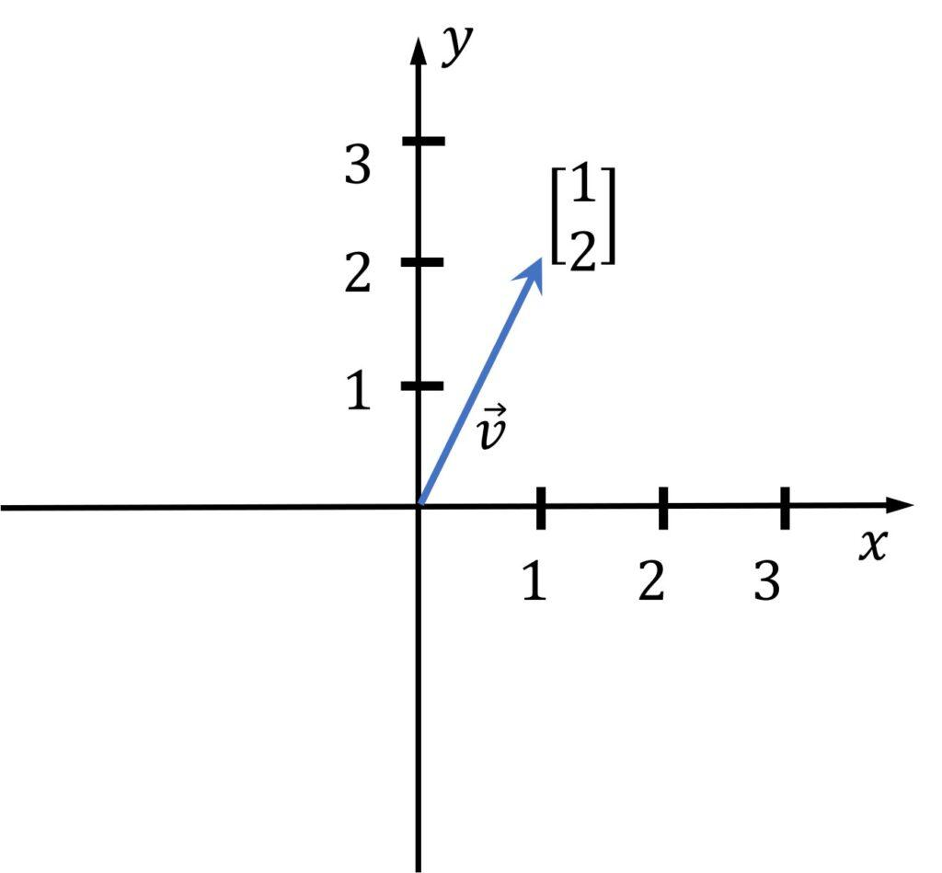
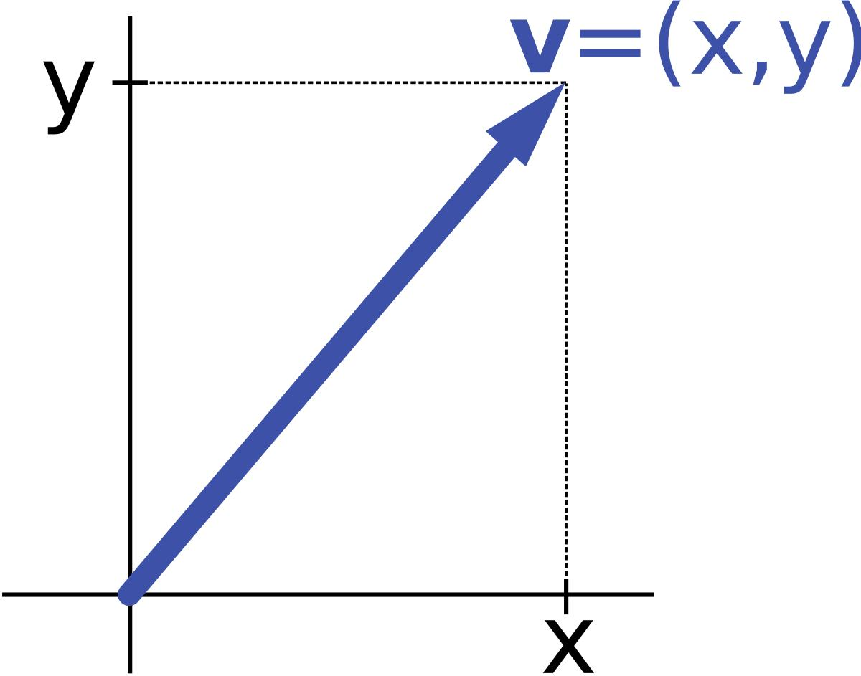
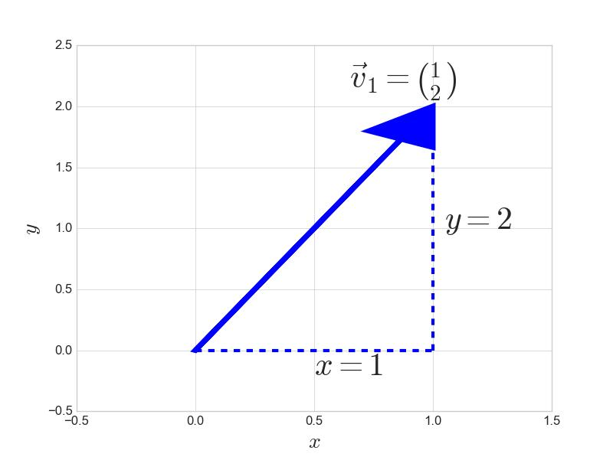
The two values correspond to:
$$x=1 \\ y=2$$
So:
$$\boxed{\left(1 , 2\right)}$$
means:
Move 1 unit along the x-axis and 2 units along the y-axis.
The lecture demonstrates exactly this interpretation of a 2D vector.

9. Magnitude of a Vector
Once a vector is represented geometrically, we can calculate its magnitude (length).
For:
$$A=\left(1 , 2\right)$$
we can use the Pythagorean theorem.
The vector forms a right triangle:
- One side = 1
- Other side = 2
- Hypotenuse = magnitude of the vector
Therefore:
$$∣A∣=\sqrt{1^{2}+2^{2}} \\ =\sqrt{1+4} \\ \boxed{∣A∣=\sqrt{5}}$$
So the distance of the point $\left(1 , 2\right)$from the origin is:
$$\boxed{\sqrt{5}}$$
This is the geometric meaning of vector magnitude in 2D.
General 2D formula
For:
$$A=\left(x , y\right)$$
the magnitude is:
$$\boxed{∣A∣=\sqrt{x^{2}+y^{2}}}$$
This is essentially the Pythagorean theorem applied to a vector.

10. Negative Components and Direction
Consider:
$$B=\left(- , 32\right)$$
Here:
- $x=-3$
- $y=2$
The negative x-coordinate means we move 3 units in the negative x-direction, while $y=2$means we move 2 units upward along the y-axis.
So the vector points in a different direction from:
$$\left(1 , 2\right)$$
The lecture uses $\left(- , 32\right)$to illustrate how the signs of vector components affect its direction.
Its magnitude would be:
$$∣B∣=\sqrt{{\left(-3\right)}^{2}+2^{2}} \\ =\sqrt{9+4} \\ =\sqrt{13}$$
Notice something important:
$${\left(-3\right)}^{2}=9$$
So the negative sign changes the direction, but when calculating magnitude, the squared value contributes positively.

11. Three-Dimensional Vectors
A 3D vector contains three components:
$$\boxed{C=\left(x , y , z\right)}$$
For example:
$$C=\left(2 , 4 , 3\right)$$
It can be represented using three axes:
- x-axis
- y-axis
- z-axis
The lecture introduces 3D vectors in this way and emphasizes that the same idea extends to higher dimensions.
In Data Science, these dimensions don't necessarily represent physical space.
For example:
$$\left[90 , 3 , 0\right]$$
could represent:
- IQ = 90
- Study hours = 3
- Fail = 0
So "3D" here simply means three components.

12. Vectors and Machine Learning
This is one of the most important parts of the lecture.
Suppose an ML model receives:
$$F_{1}=\text{IQ} \\ F_{2}=\text{Study Hours}$$
and needs to predict:
$$Y=\text{Pass/Fail}$$
Every record can be represented as:
$$x=\left[F_{1} , F_{2}\right]$$
For example:
$$x=\left[90 , 2\right]$$
or:
$$x=\left[100 , 3\right]$$
The ML algorithm can then operate mathematically on these vectors.
The lecture emphasizes that each record in the dataset can be represented in vector form.
Mental model
Think of a vector as the mathematical representation of one data point.
For example:
Student
│
├── IQ = 90
└── Study Hours = 2
↓
[90, 2]
↓
ML Model
↓
Prediction

13. Classification Example
Suppose we plot students according to:
- x-axis → IQ
- y-axis → Study Hours
We could have:
- Pass points
- Fail points
The ML model may learn a boundary separating the two groups.
The lecture illustrates this using a line represented by:
$$\boxed{y=mx+c}$$
A new vector/data point can then be evaluated relative to that boundary to determine its predicted class.
The important point for this lecture is not the detailed mathematics of classification.
It is:
Each data point can be represented as a vector, and those vectors can be plotted and mathematically processed by ML algorithms.

14. Unit Vectors
A unit vector is a vector whose magnitude is:
$$\boxed{1}$$
The lecture introduces the standard unit vectors in 2D:
$$\hat{i}$$
for the x-direction, and
$$\hat{j}$$
for the y-direction.
They each have magnitude 1.

Example: Representing $\left(3 , 3\right)$
Consider:
$$v=\left(3 , 3\right)$$
This means:
- 3 units in the x-direction
- 3 units in the y-direction
Using unit vectors:
$$\boxed{v=3\hat{i}+3\hat{j}}$$
Why?
Because:
$$3\hat{i}$$
means three unit movements in the x-direction, and:
$$3\hat{j}$$
means three unit movements in the y-direction.
Therefore:
$$\boxed{3\hat{i}+3\hat{j}}$$
represents the vector $\left(3 , 3\right)$.
Remember
$$∣\hat{i}∣=1 \\ ∣\hat{j}∣=1$$
Unit vectors are basically building blocks for describing direction/components.
The lecture notes that the deeper importance of unit vectors will be discussed later.

15. Vectors in Gaming and Simulations
The lecture gives a practical example from the gaming industry.
Suppose a car in a game has:
$$200\text{ km/h}$$
and is moving in a particular direction.
Another car may be moving at:
$$100\text{ km/h}$$
in another direction.
Speed + direction can be represented using vectors.
The game engine can use this information to determine things such as:
- Movement
- Collision
- Direction after collision
- Resulting motion
Similarly, waves in a game can have a direction and magnitude, and a boat interacting with those waves can respond accordingly.
The lecture uses these examples to show why vectors are useful in simulations and gaming environments.
Core idea
Object
↓
Position + Movement
↓
Vector representation
↓
Mathematical calculations
↓
Simulation / Animation

16. A Very Important Property of Vectors
Suppose we have a vector pointing from one point to another.
If we move the entire vector somewhere else without changing:
- Its length
- Its direction
then it is still the same vector in terms of its magnitude and direction.
Only its starting/origin point has changed.
The lecture demonstrates this using the example of moving a box and emphasizes that changing the origin does not change the vector's length or direction.
Think of it this way
Imagine an arrow:
A ─────────→ B
Now move the whole arrow somewhere else:
C ─────────→ D
If:
- $AB$and $CD$have the same length
- They point in the same direction
then they represent the same vector displacement.
Key takeaway
A vector is determined by its magnitude and direction, not by where you draw it.
This property is particularly important when you start learning vector addition and other vector operations.

Scalar vs Vector
Scalar | Vector
Single numerical value | Ordered list of values
Represents magnitude/quantity | Can represent magnitude + direction
No direction | Can have direction
Example: 25°C | Example: $\left(3 , 2\right)$
Example: count = 5 | Example: $\left[90 , 3\right]$
Often represents one calculated value | Often represents one complete data point
In Data Science
The distinction to remember is:
$$\boxed{\text{Scalar}=\text{one value}} \\ \boxed{\text{Vector}=\text{multiple ordered values}}$$

Important Formulas
1. Magnitude of a 2D Vector
For:
$$v=\left(x , y\right) \\ \boxed{∣v∣=\sqrt{x^{2}+y^{2}}}$$

2. Magnitude Example
For:
$$v=\left(1 , 2\right) \\ ∣v∣=\sqrt{1^{2}+2^{2}} \\ =\sqrt{5}$$

3. Unit Vector
$$\boxed{∣\hat{v}∣=1}$$
A unit vector has magnitude exactly 1.

4. Unit-vector representation
For:
$$v=\left(3 , 3\right) \\ \boxed{v=3\hat{i}+3\hat{j}}$$
where $\hat{i}$and $\hat{j}$are unit vectors along the x- and y-directions.

Important Points to Remember
- A scalar is one numerical value.
- A vector is an ordered collection of values.
- In physics, vectors are commonly described using magnitude and direction.
- In Data Science, vectors commonly represent data points/features.
- The number of components determines the vector's dimension.
- A vector such as $\left[90 , 3\right]$can represent a student with IQ 90 and 3 study hours.
- A vector does not need to represent a physical direction when used in Data Science.
- Vector magnitude represents the vector's length.
- Unit vectors have magnitude 1.
- Moving a vector without changing its length or direction does not change the vector itself.

Quick Revision
Core Ideas
- Scalar → one numerical value.
- Vector → ordered list of values.
- In Data Science, one observation/data point can be represented as a vector.
- Number of components = vector dimension.
- Vectors can represent 2D, 3D, 500D, 5000D, etc.
- Vector magnitude can be calculated using the Pythagorean theorem in 2D.
- A unit vector has magnitude 1.
- The position where a vector is drawn does not change its magnitude or direction.
Important Formulas
$$\boxed{∣v∣=\sqrt{x^{2}+y^{2}}} \\ \boxed{∣\hat{v}∣=1} \\ \boxed{\left(3 , 3\right)=3\hat{i}+3\hat{j}}$$
Data Science Connection
$$\boxed{\text{Data Record}→\text{Numerical Features}→\text{Vector}→\text{ML Model}}$$
For example:
$$\text{Student: IQ=90, Hours=2}$$
becomes:
$$\boxed{\left[90 , 2\right]}$$
This vector can then be used mathematically by an ML algorithm.
Self-Check
- What is the difference between a scalar and a vector?
- Why can a Data Science vector represent data even without a physical direction?
- What does the dimension of a vector mean?
- What is the magnitude of $\left(3 , 4\right)$?
- Why is $\left(3 , 3\right)$written as $3\hat{i}+3\hat{j}$?
One idea to remember before moving on:
In Data Science, think of a vector primarily as a mathematical representation of a data point — an ordered collection of feature values.

